Suryadatta College of Management Information Research and Technology, SCMIRT, Pune
NATIONAL SERVICE SCHEME
2025-2026
Report on 7 Days NSS Special Camp at Kule, Mulshi
1. Introduction
The National Service Scheme (NSS) Special Camp is an intensive community-oriented programme aimed at inculcating social responsibility, leadership qualities, and a spirit of selfless service among students. A Seven-Day NSS Special Camp was successfully organized by the NSS Unit of SCMIRT, Pune at Kule village from 16 January 2026 to 22 January 2026. The camp was conducted under the able guidance of Dr. Sandeep Dhore, Programme Officer, with the active participation of 25 NSS volunteers. The camp aimed at the holistic development of the village community along with the personality development of the volunteers.
2. Objectives of the Camp
The main objectives of the NSS Special Camp were:
- To create awareness about cleanliness, health, hygiene, and environmental protection
- To promote social responsibility and leadership qualities among NSS volunteers
- To understand rural life and identify grassroots-level issues
- To encourage community participation in developmental activities
- To contribute towards sustainable village development
3. Details of the Camp
- Name of the College: Suryadatta College of Management Information Research and Technology, SCMIRT, Pune
- Programme: NSS Special Camp
- Duration: 16/01/2026 to 22/01/2026 (Seven Days Residential Camp)
- Venue: Kule Village
- NSS Unit Strength: 25 Volunteers
- Programme Officer: Dr. Sandeep Dhore & Chaitali Salunke
- Beneficiaries: Residents of Kule Village
4. Day-wise Activities
Day 1 (16/01/2026): Inauguration and Village Survey
On 16th Jan, a session was undertaken by Prin. Dr. Shrikant Jagtap and Vice-Prin. Dr. Khushali Oza of the college. They guided NSS volunteers about the importance in conserving the cultural heritage and the development of rural areas. Volunteers and the NSS staff left the college premises at 9:00 am and reached the camp site at 10:30 am. The camp commenced with a formal inaugural ceremony in the presence of village Sarpanch & other authorities, senior citizens, and local residents. The objectives, importance, and schedule of the camp were explained to the villagers. NSS volunteers conducted a detailed village survey to identify issues related to sanitation, health, education, water resources, and social welfare. The camp activities started with cleaning the surroundings at the Shri Bhairawnath Temple and ZP School, Kule. After this, cleaning activities were done. Cleaning of the surroundings of Shri Bhairawnath Temple, cleaning of rooms of ZP school and ZP ground were done by the NSS volunteers. Inauguration session started at 11 am having the Sarpanch of the village Mr. Akash Sathe, Deputy Sarpanch Mrs. Deepali Sathe, Mrs. Hemlata Mankar, Police Patil as a guest. Dr. Sandeep Dhore Sir, NSS coordinator felicitated him and gave a welcome speech to all the volunteers. He guided us about the activities which would be happening and gave each of the volunteer an individual responsibility for the next 7 days. The day concluded by taking a meeting in the evening about planning and plotting of the activities of next day.

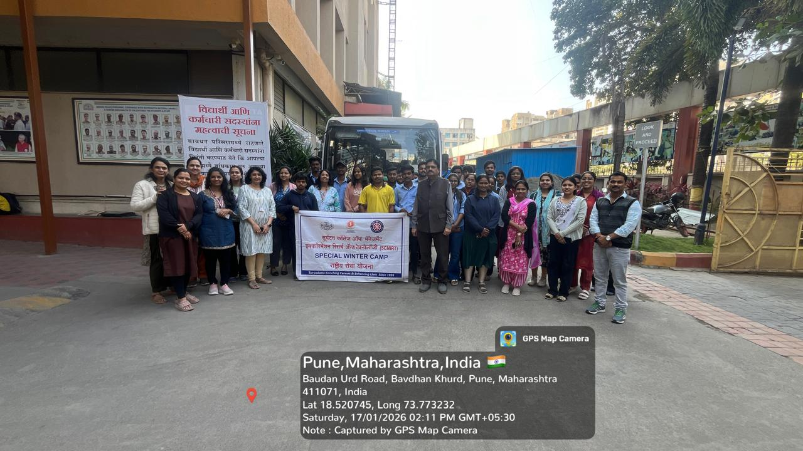
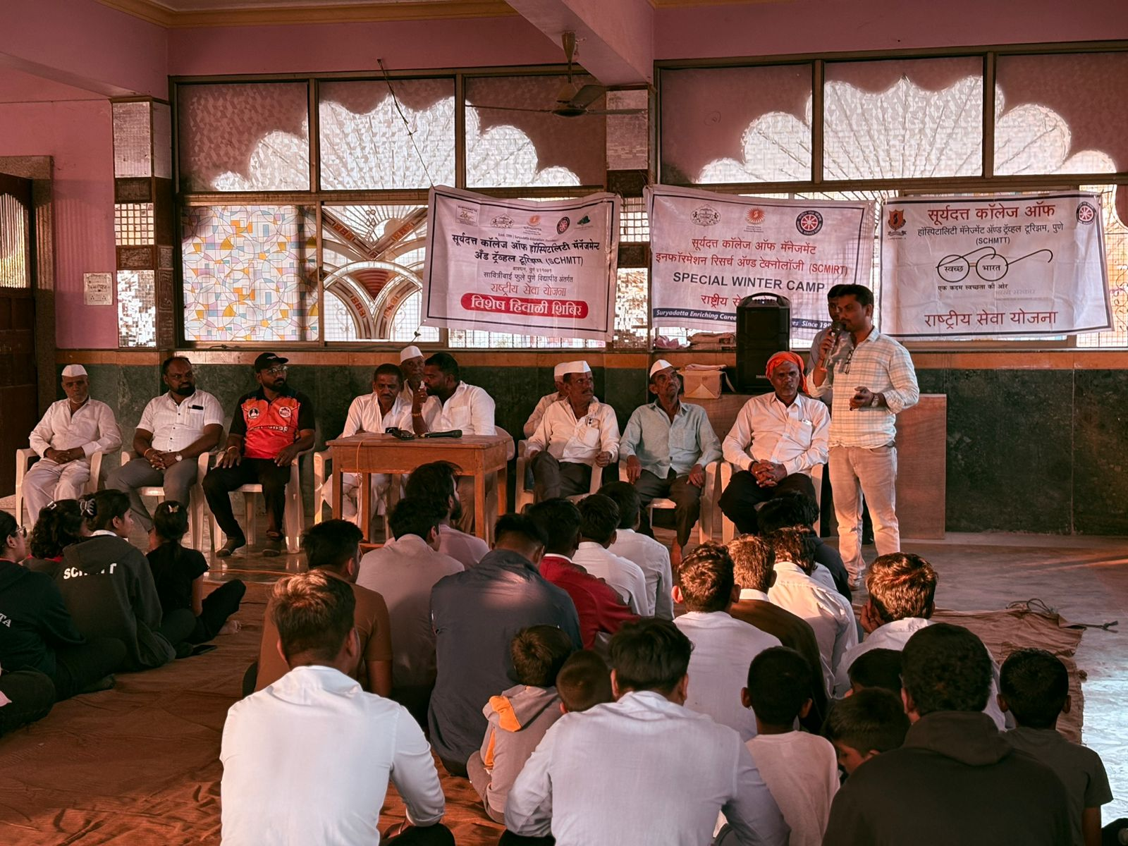
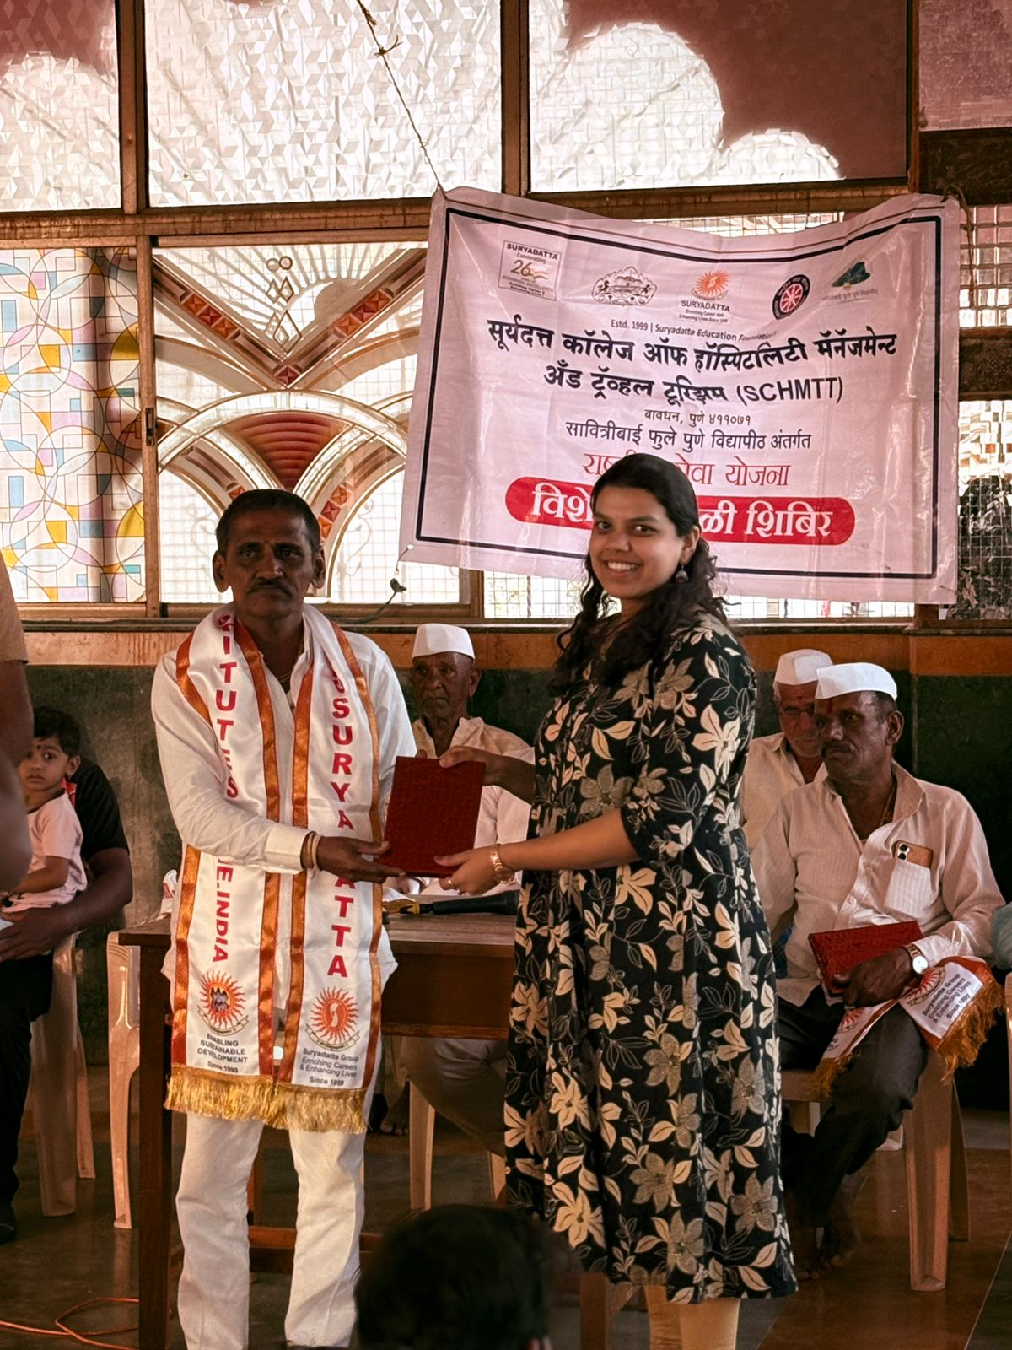
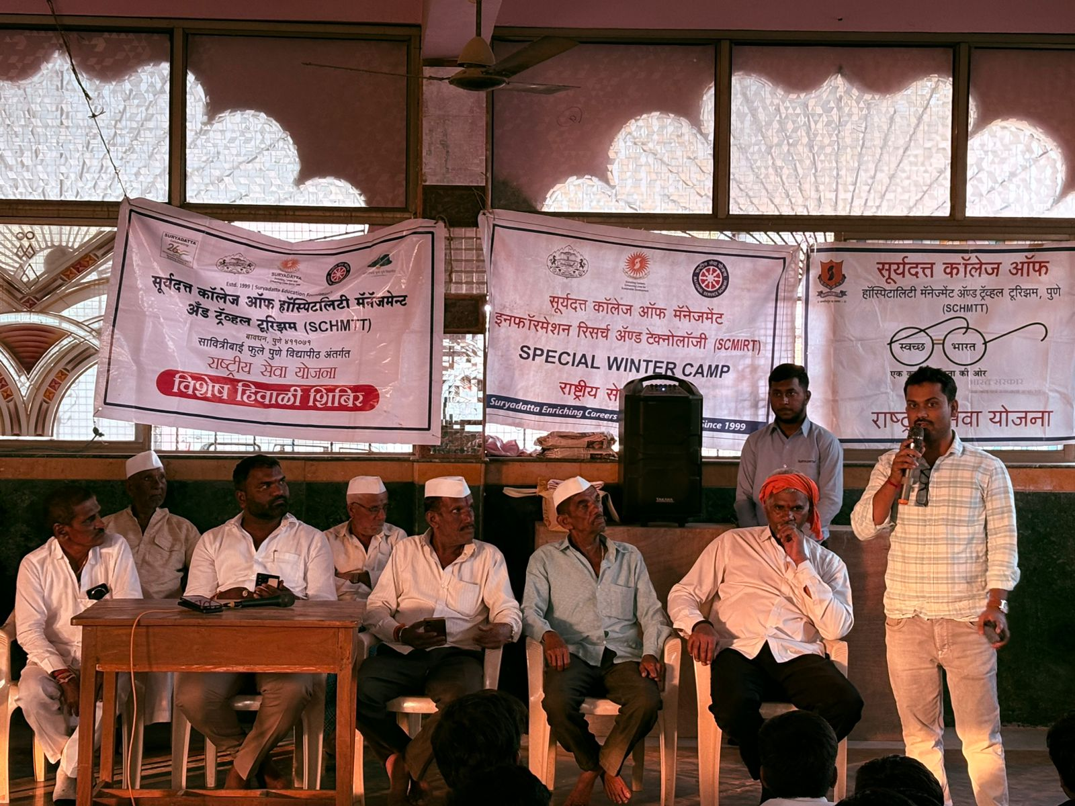
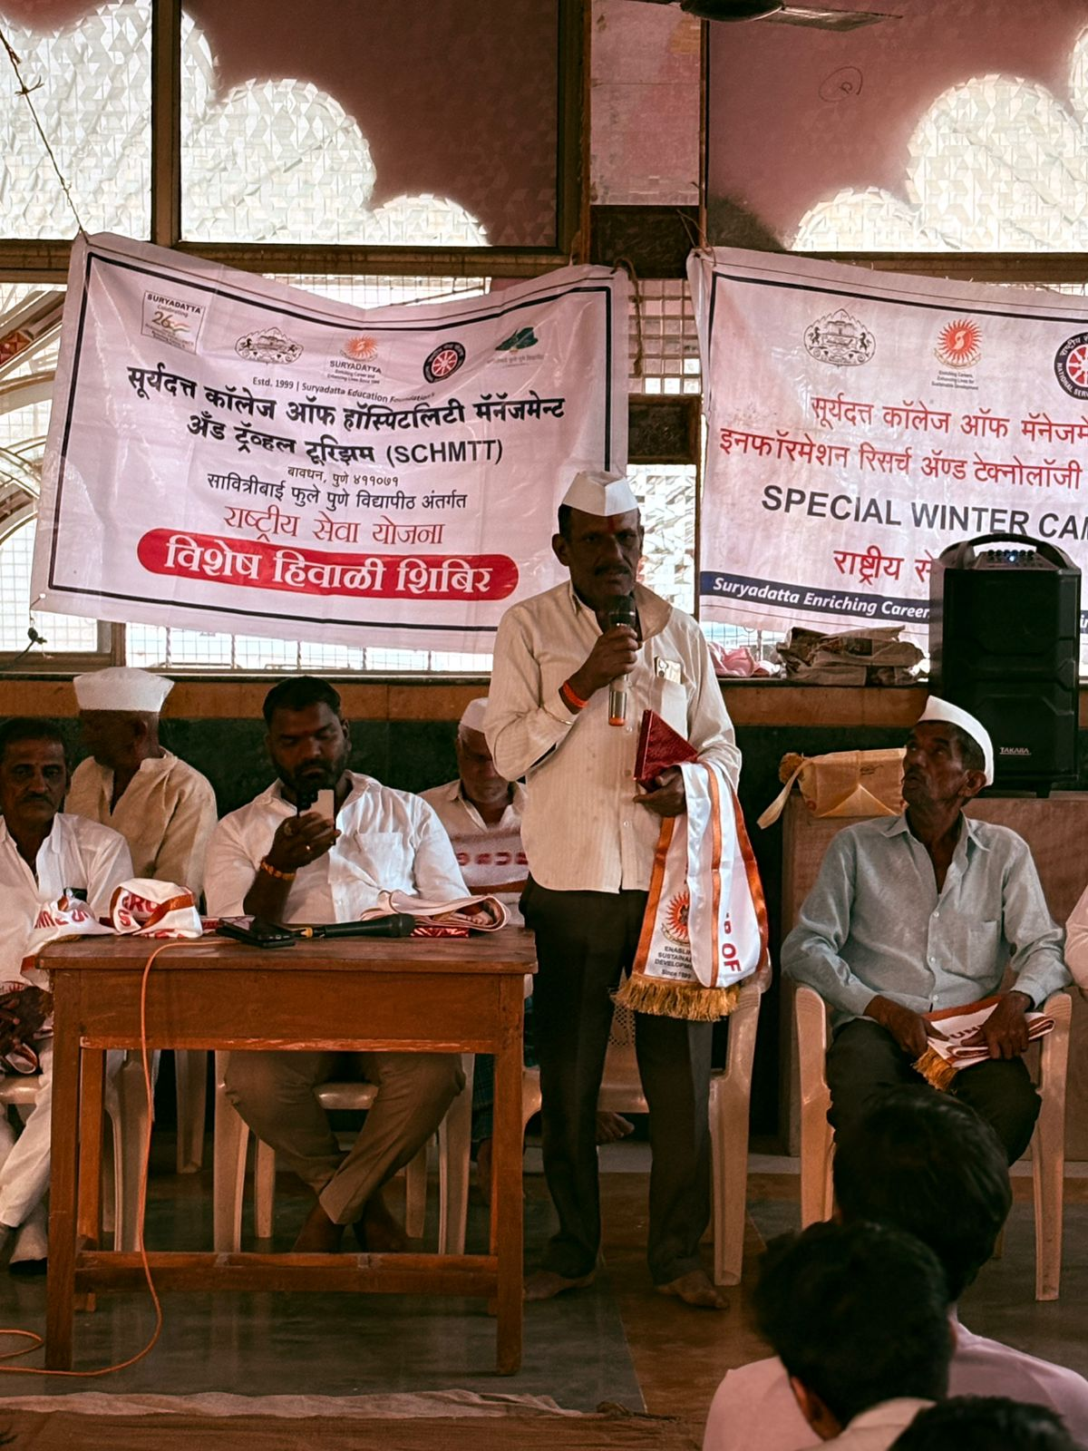

Day 2 (17/01/2026): Cleanliness Drive & Rally on Road Safety
The second day started at 6 am with a warm up, Yoga and exercises. A cleanliness drive was organized in public places such as village roads, school premises, and common areas. Volunteers created awareness about cleanliness, waste segregation, and the importance of maintaining a hygienic environment under the initiative of Swachh Bharat Abhiyan. After the breakfast, some of the volunteers were sent for the lunch preparation while the volunteers went to interact with the villagers of Kule. After that a Rally on Road safety and De-addiction of tobacco & alcohol were conducted by NSS volunteers. NSS students spread the awareness regarding De-addictions. The day came to an end with the dinner wind up at 9:30 pm.
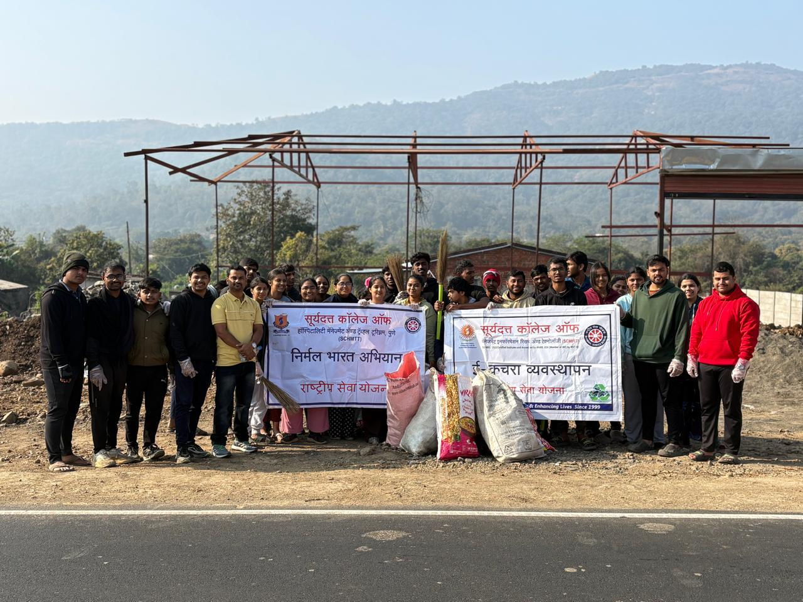
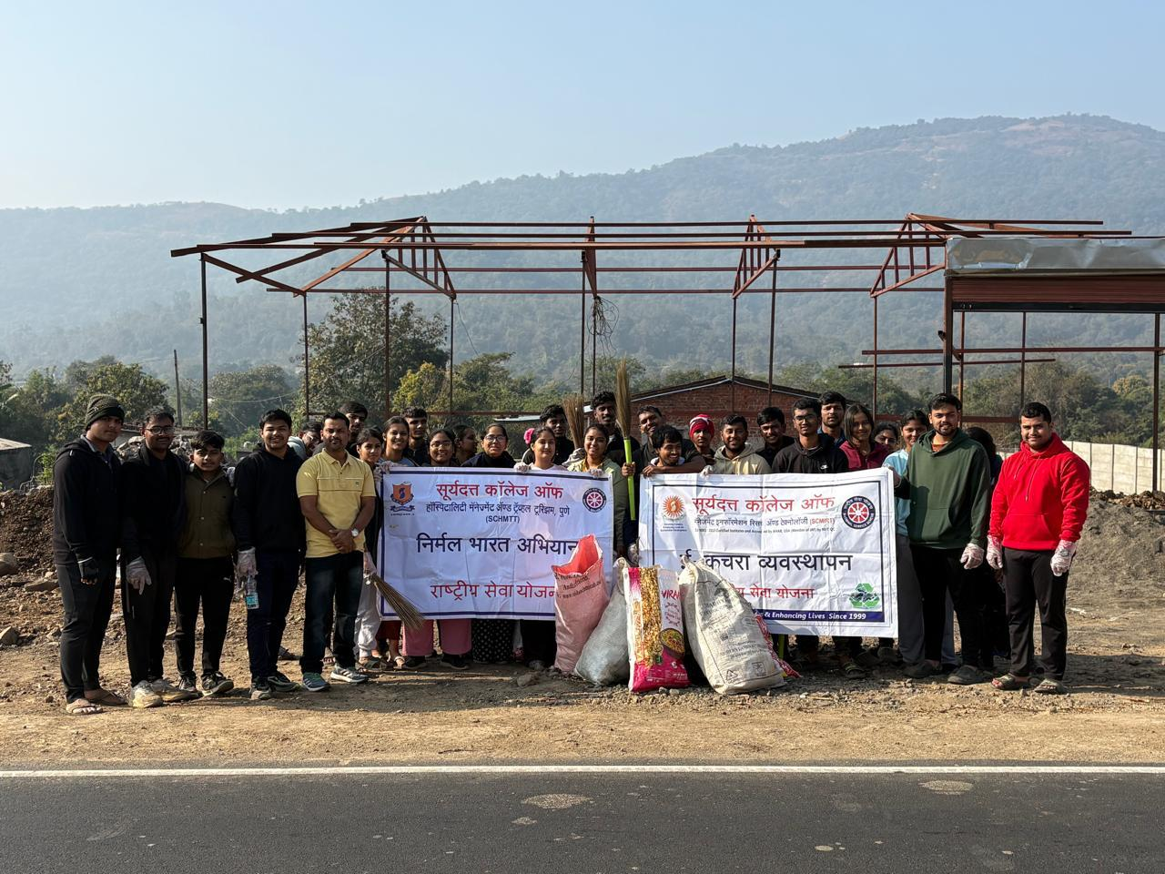
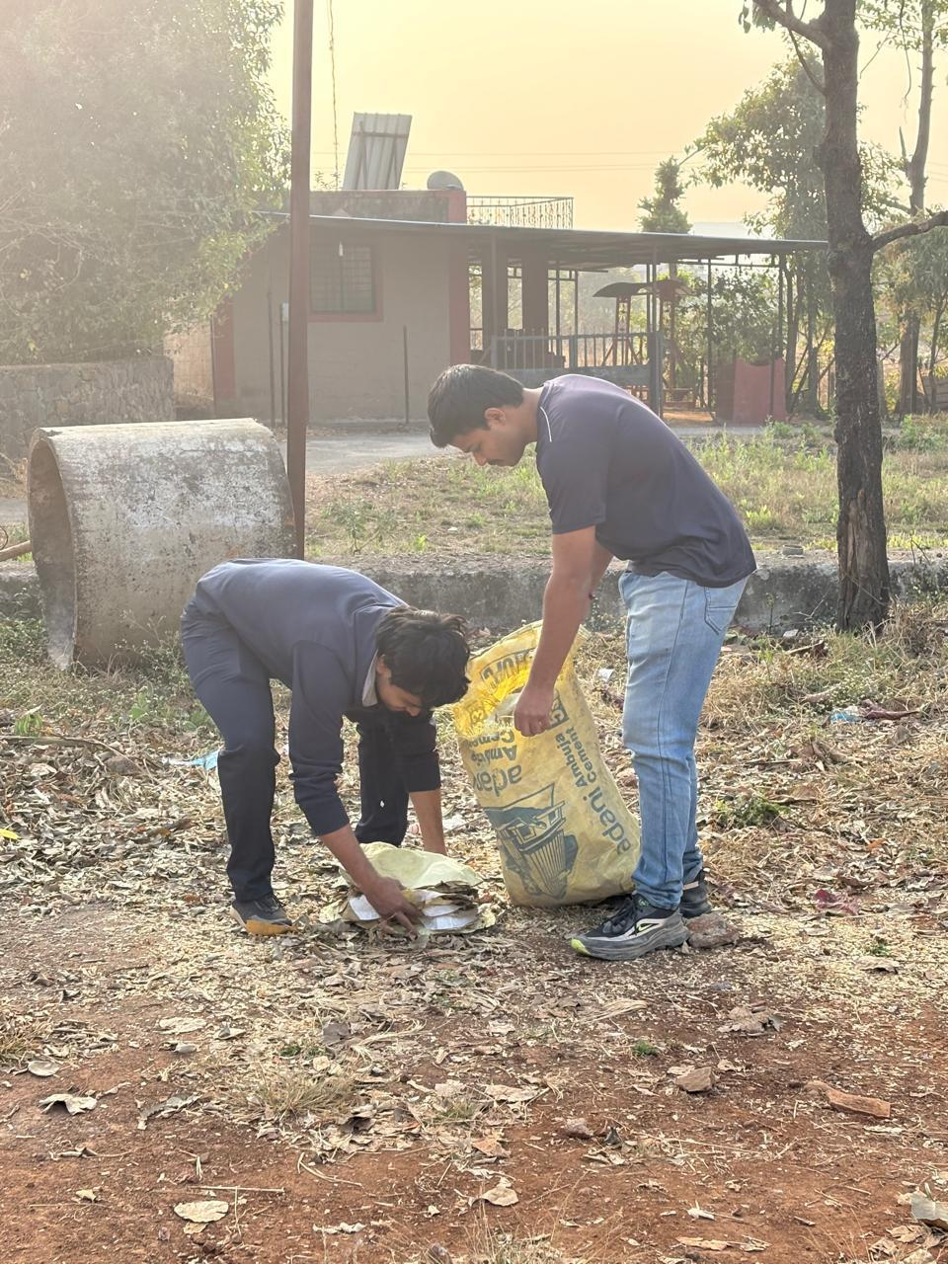
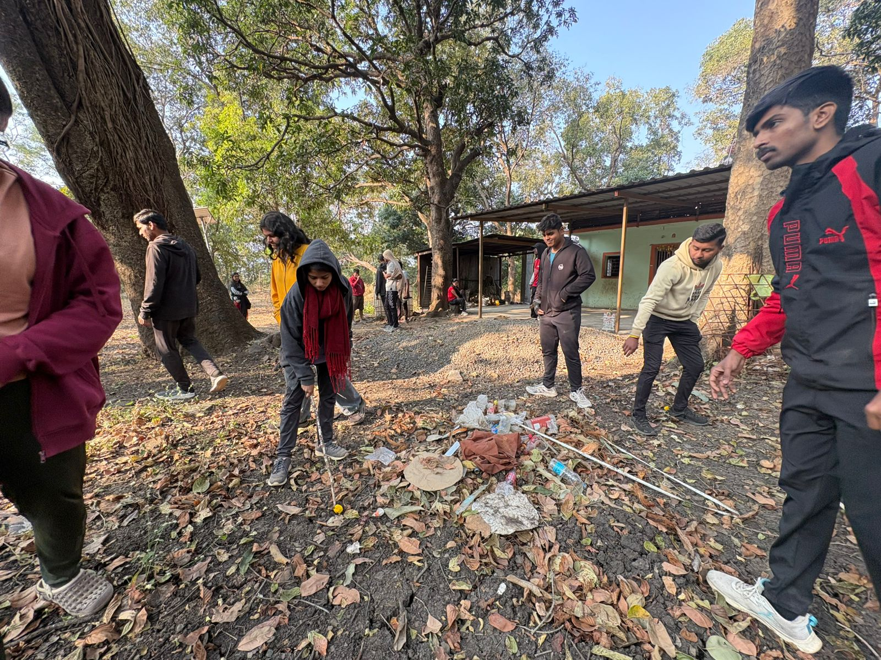
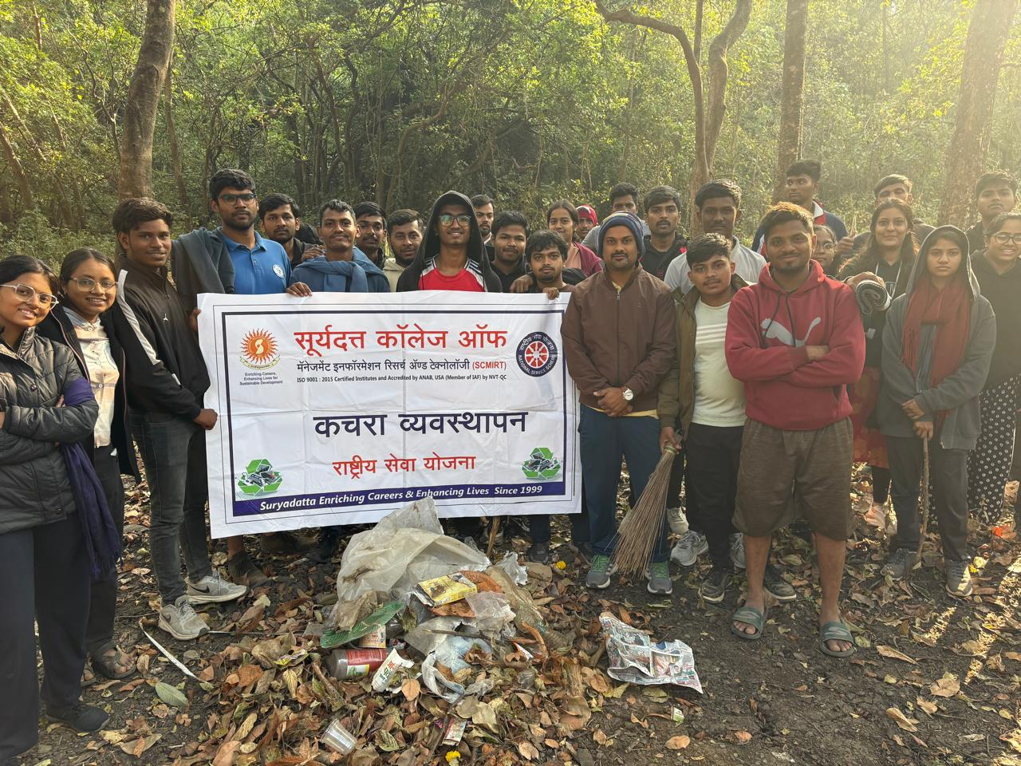
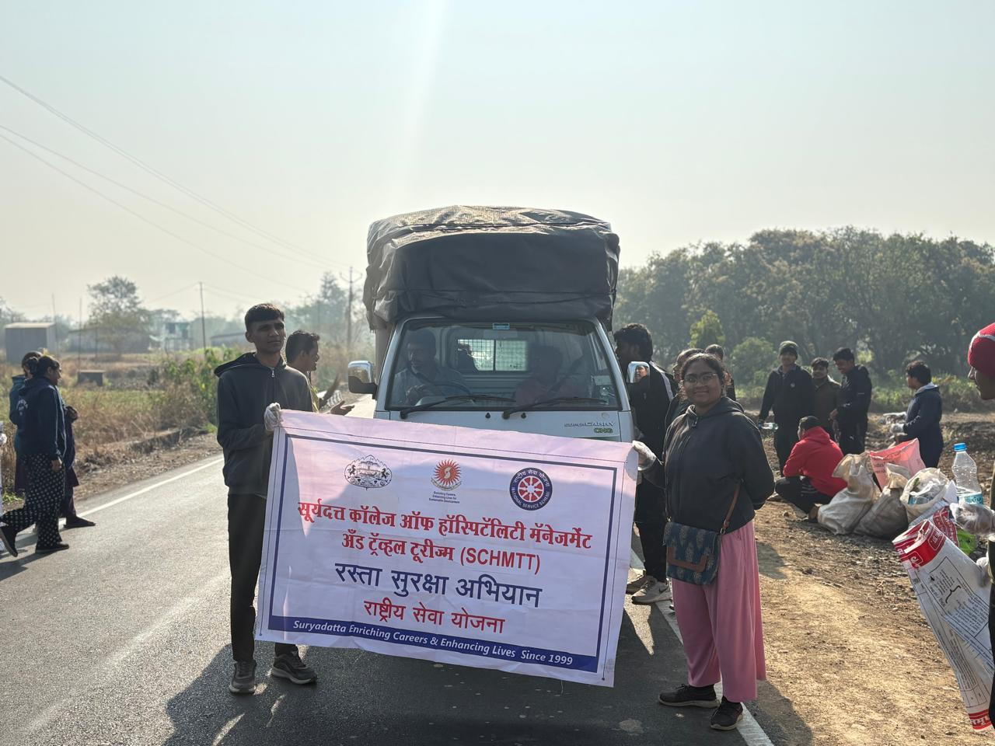

Day 3 (18/01/2026): Tree Plantation, Environmental Awareness & Guest session by Dr. Sunil Dhangar
The day started at 6 am with a warm up, Yoga and exercises. The regular cleaning activities were also taken. After the breakfast, some of the volunteers were sent for the lunch preparation while the volunteers went to interact with the villagers of Kule. NSS volunteers tried to understand the villagers life and about their day-to-day problems. Tree plantation activities were conducted with the support of villagers to promote environmental sustainability. Different kinds of plants such as Mango, Nirgudi, Almond, Papaya, Babhul , Umbar , etc were planted by the volunteers and the students of ZP school . On each of the plant, a plate of scientific and the common name of the plant, their advantages to the health were written in Devnagari script. Lunch winded up at 4:00pm. NSS volunteers also organized awareness sessions on environmental conservation, water conservation, and the importance of protecting natural resources, followed by tree plantation drive the guest session was conducted by Dr. Sunil Dhangar, Renowned anchor and motivational speaker on Personality Development through NSS. He gave various living examples and shared his own the experiences. He told the journey from supervisor on building construction side to renowned anchor of Maharashtra. He inspired students that to get successful doesn’t require apt financial condition of the family. He sung various songs and created the happiest mood of the volunteers. The session was concluded after the vote of thanks by Ms. Shravani Kulkarni
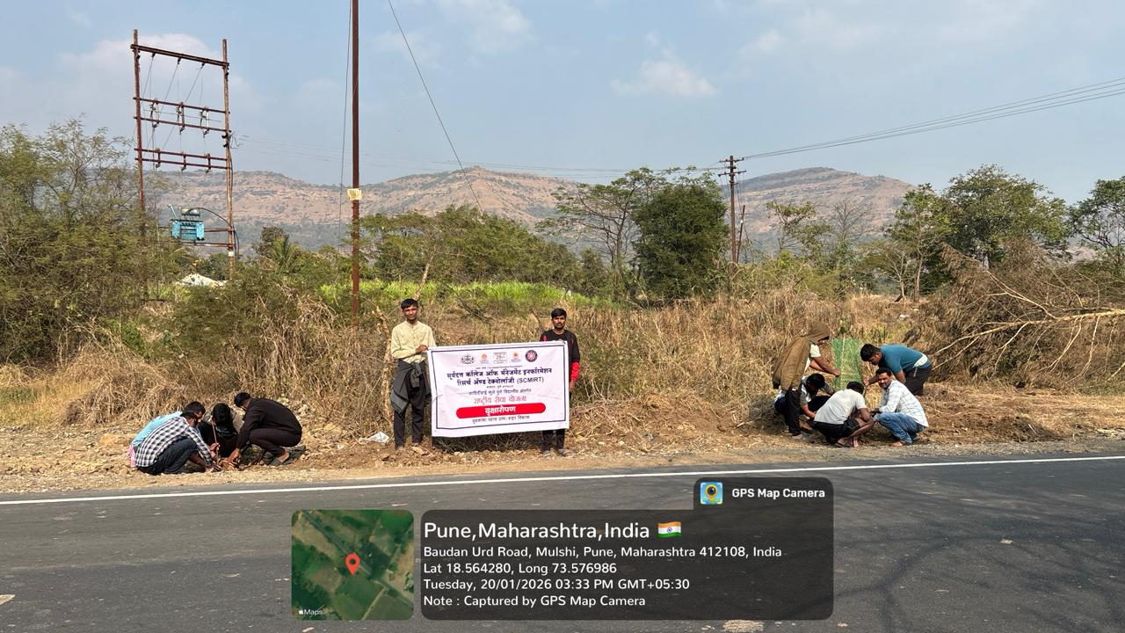

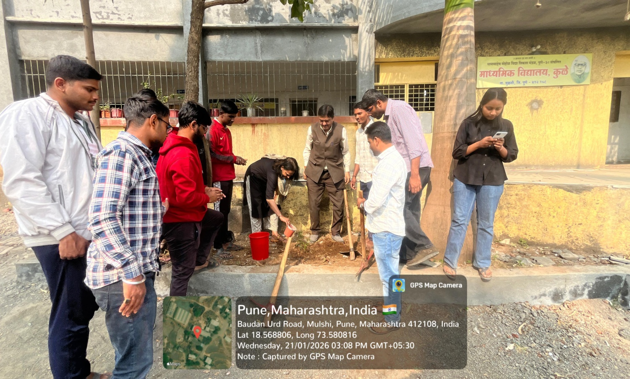
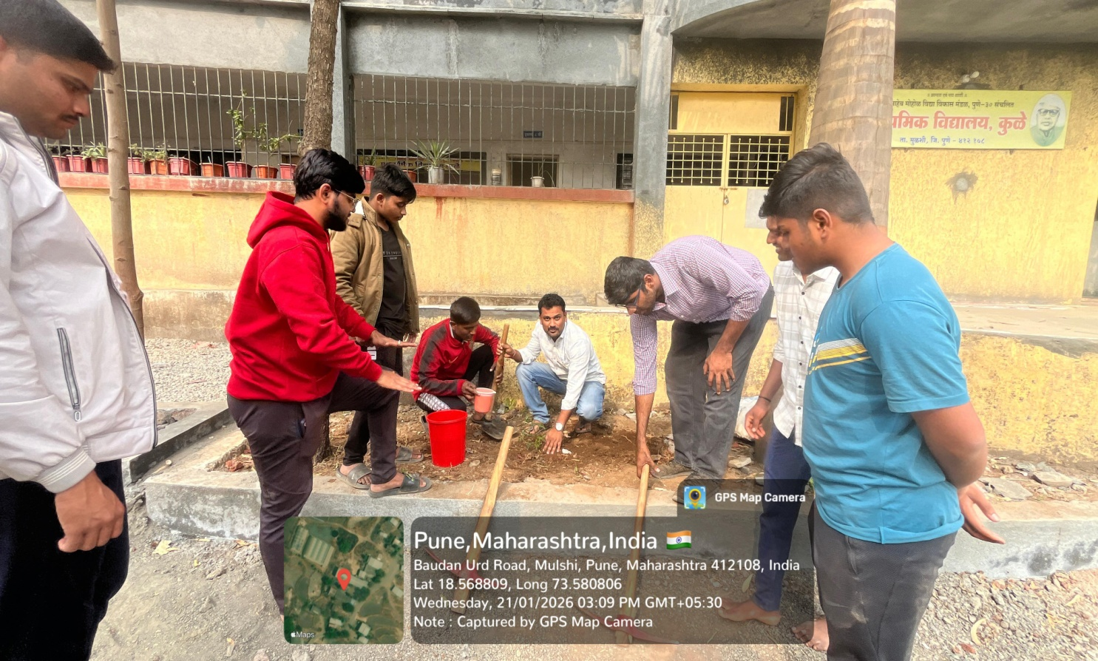
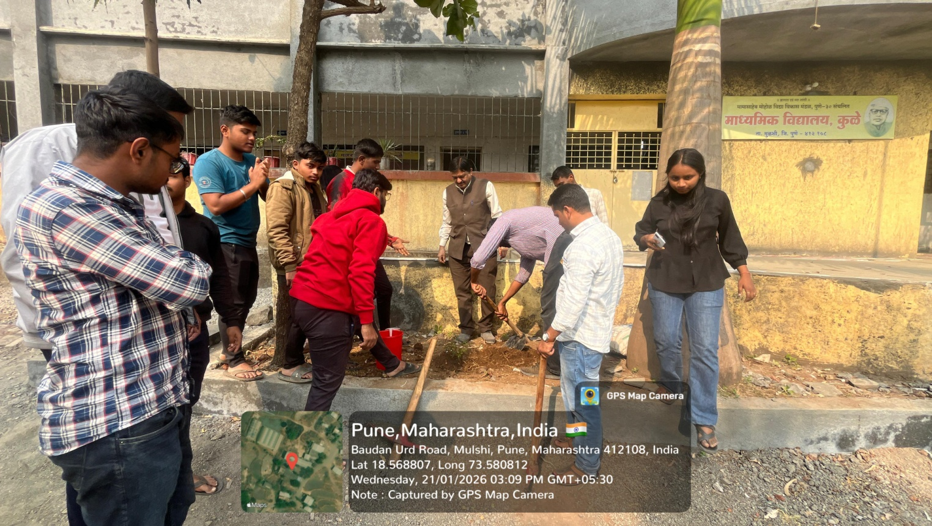

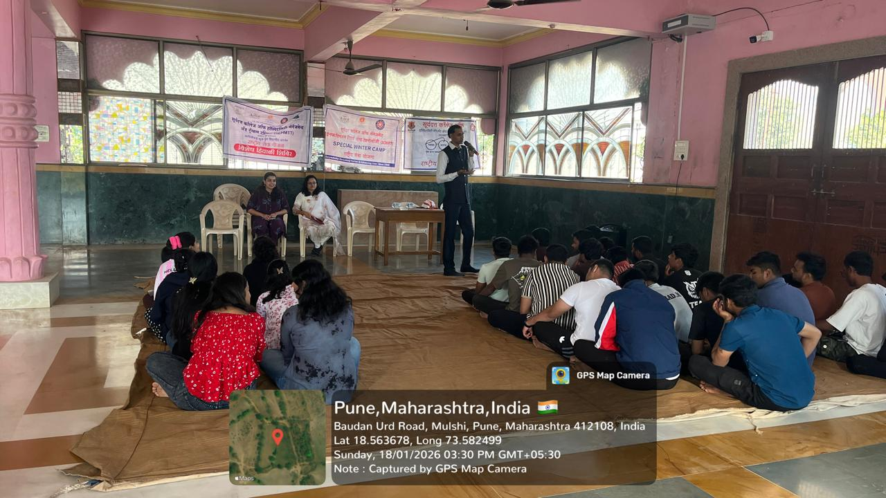
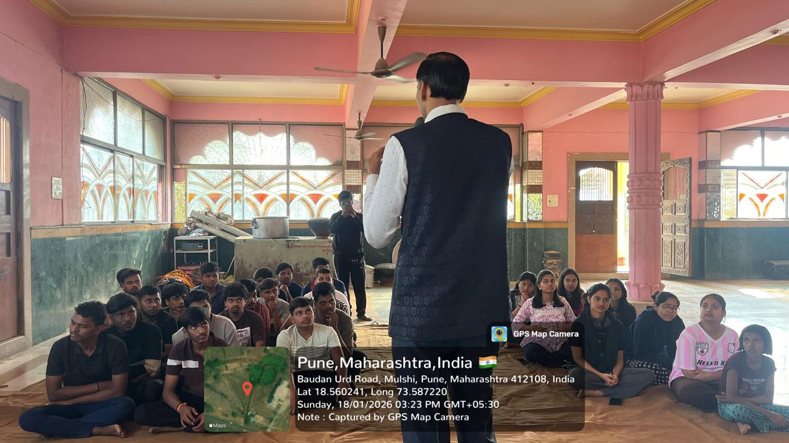
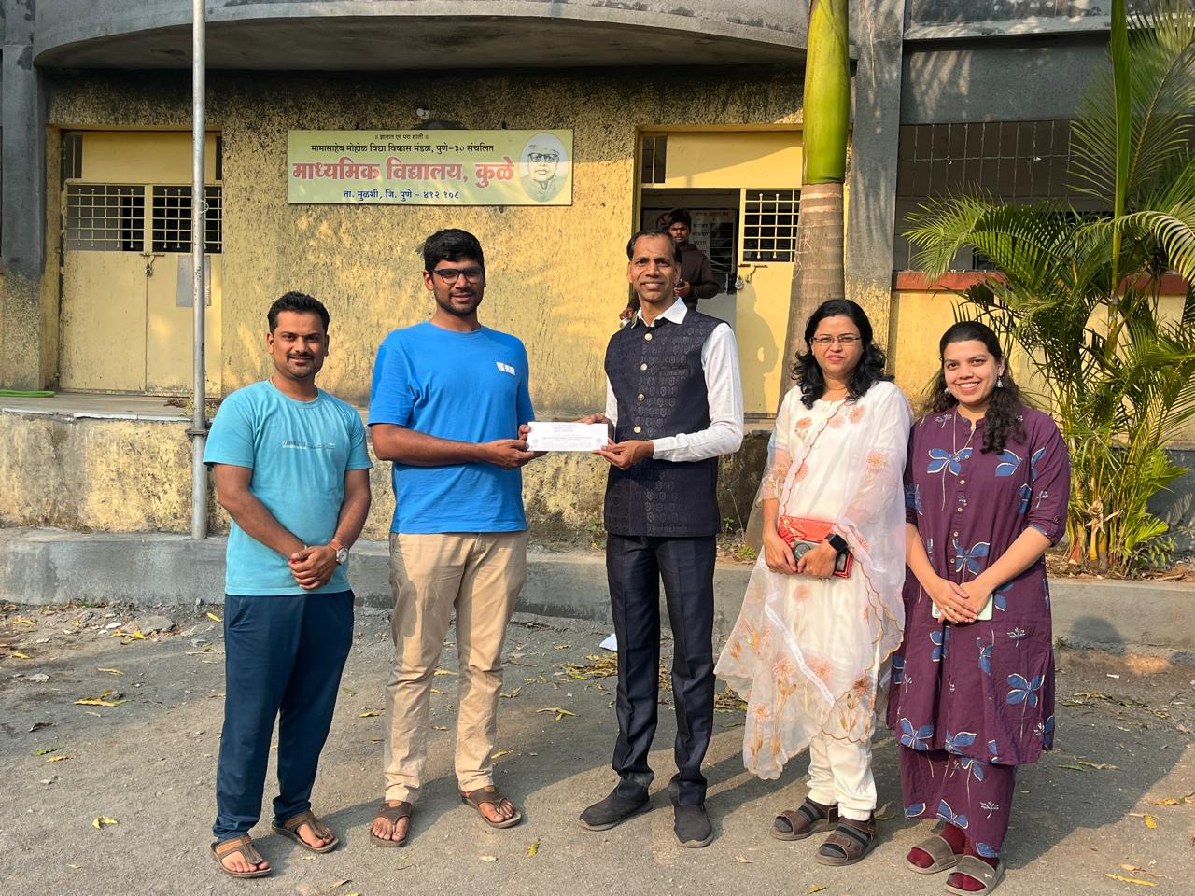
Day 4 (19/01/2026): Health & Hygiene Awareness. Guest Session- Prof. Sandhya Sharma
Fourth day commenced with the volunteers doing their given responsibilities and daily activities. After the lunch, Health and hygiene awareness programs were conducted focusing on personal hygiene, balanced diet, preventive healthcare, and sanitation practices. Information regarding government health schemes was shared with villagers, with special emphasis on women’s health and child care. After that a guest session were conducted by Asst. Prof. Sandhya Sharma on Sex Education and women empowerment.
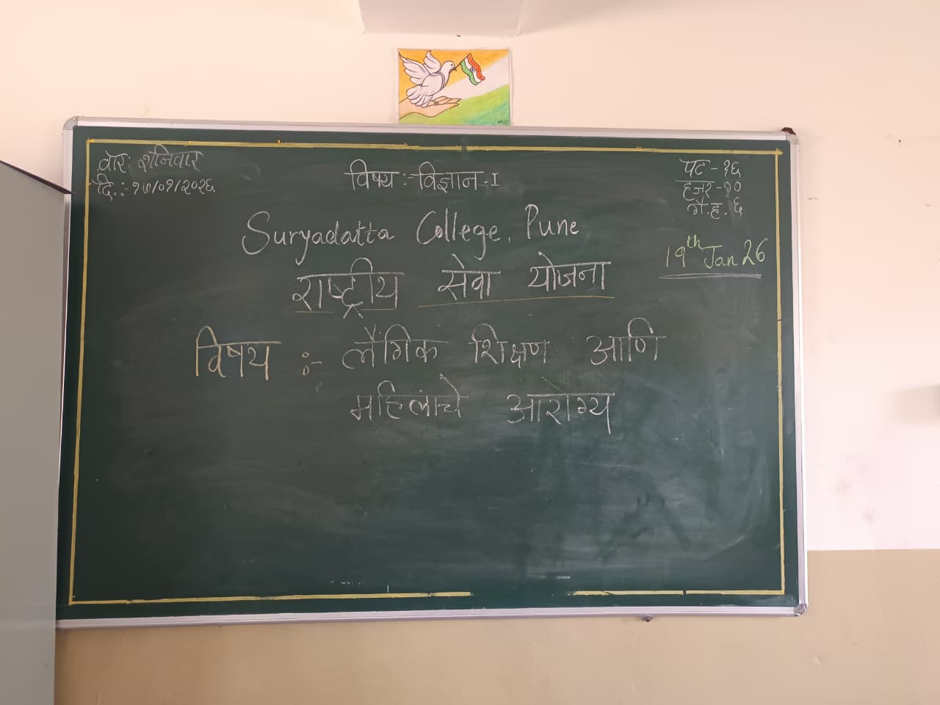
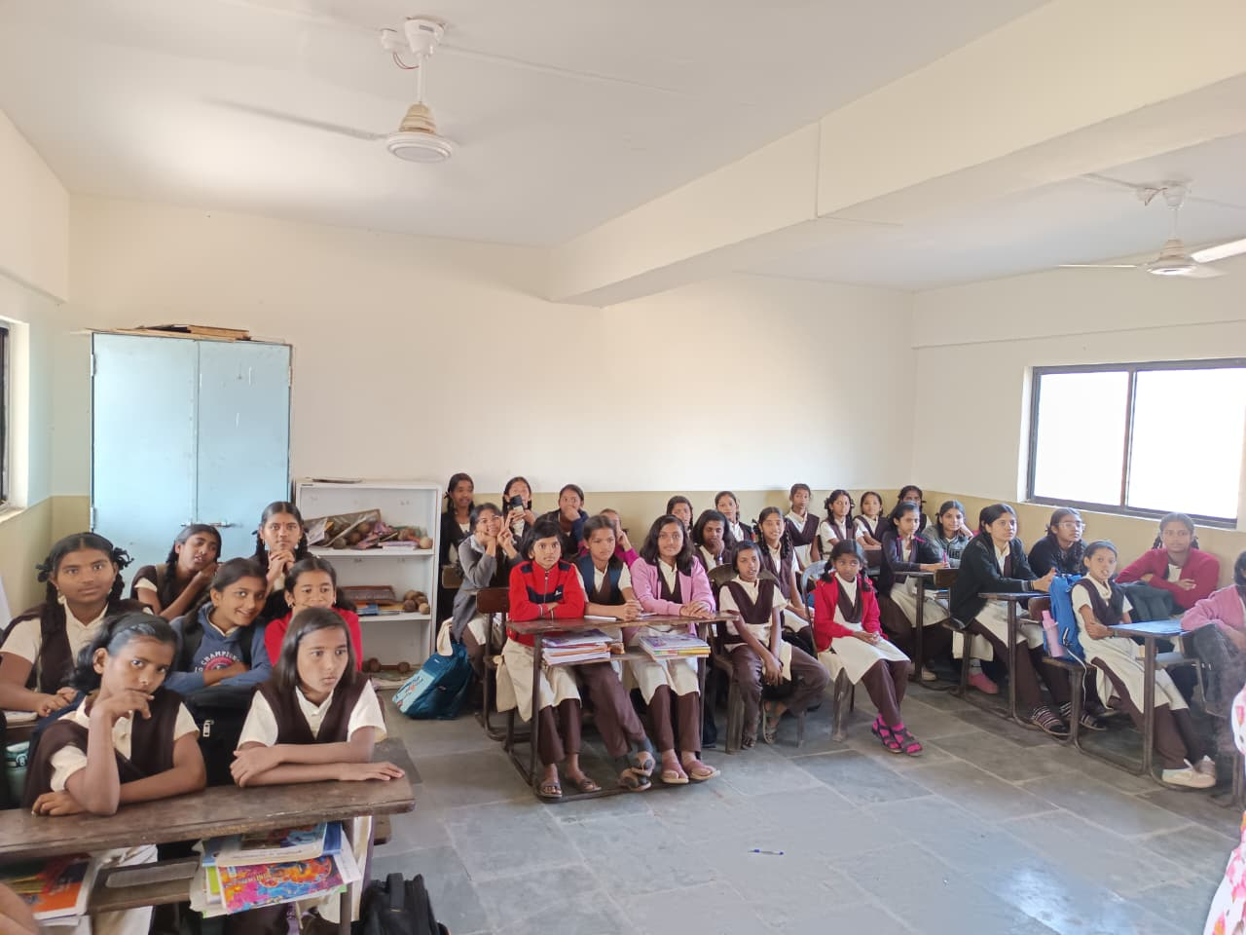
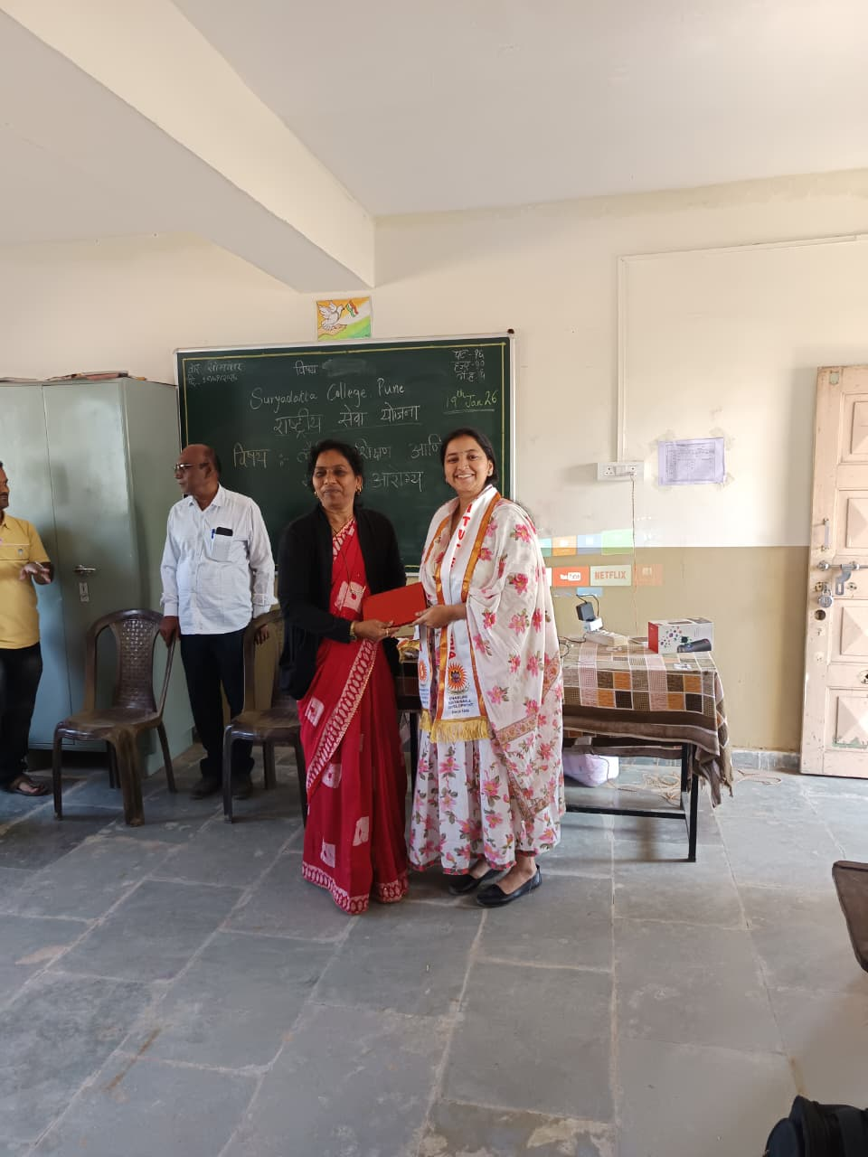

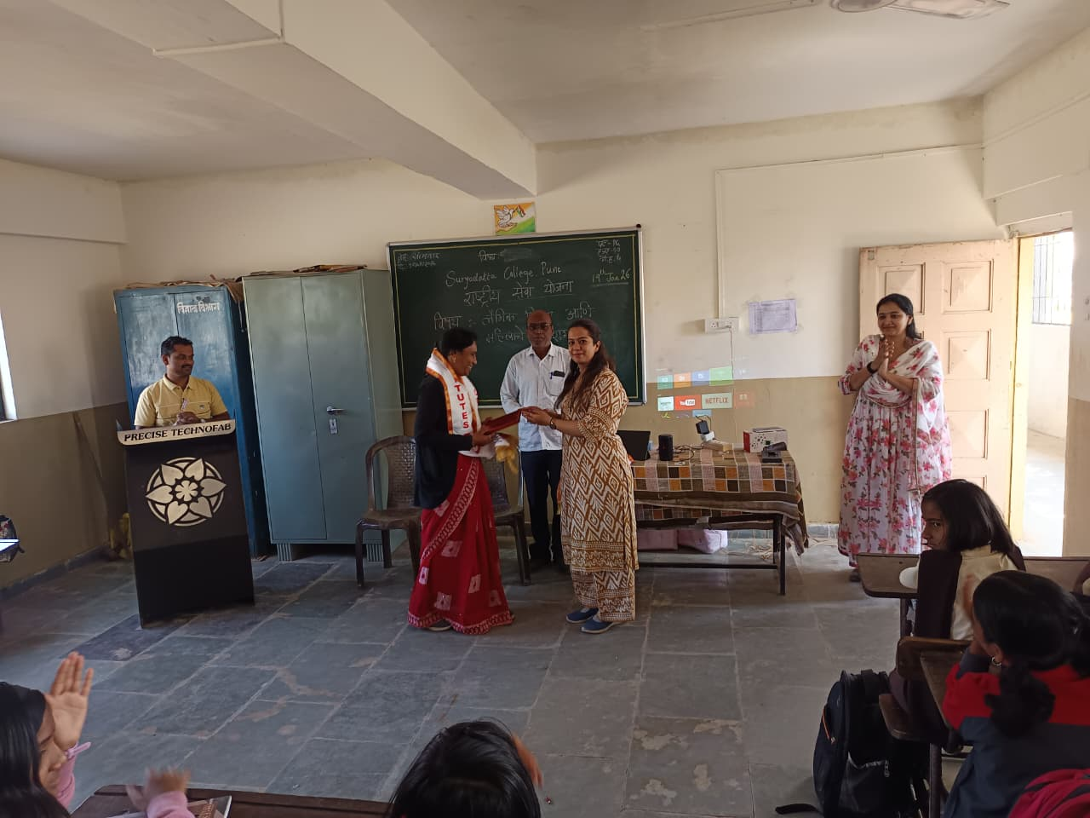
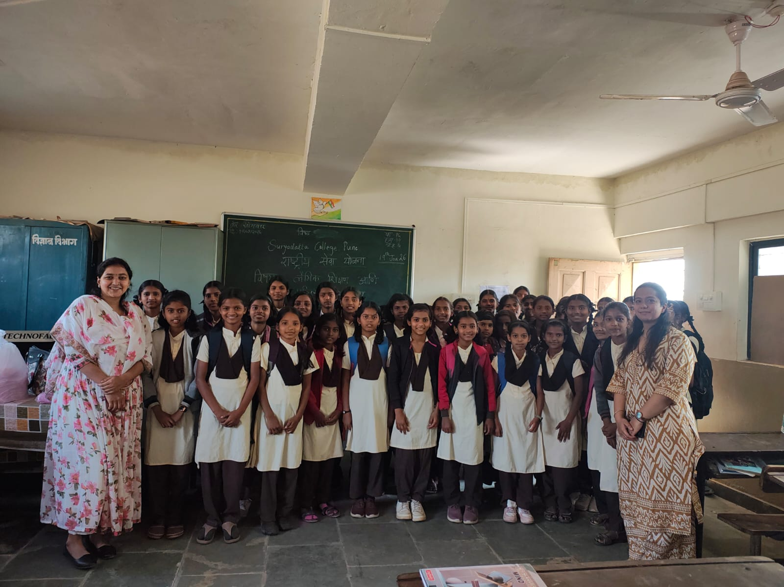
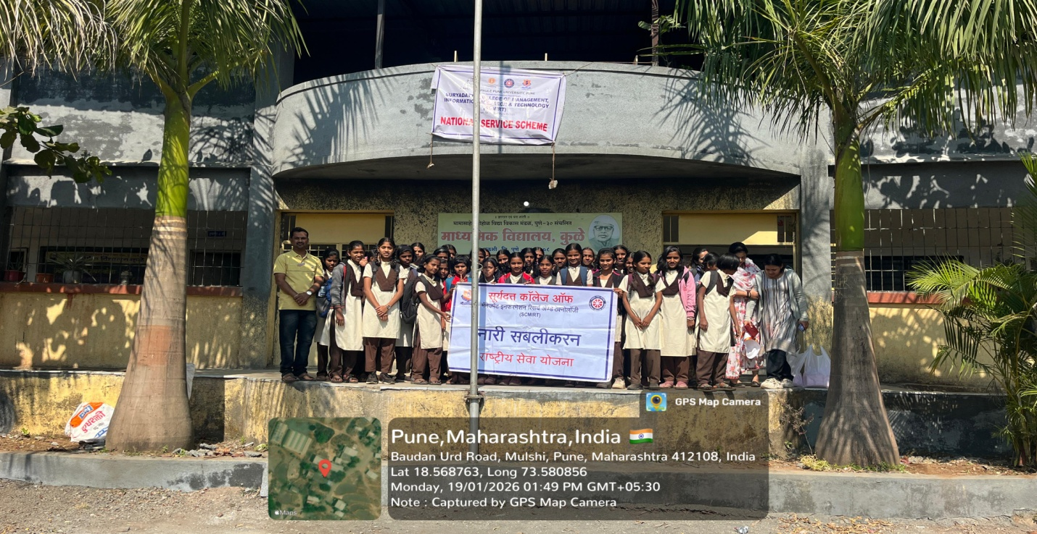

Day 5 (20/01/2026): Educational and Social Awareness Activities. Guest Session by Dr. Soniya Karade on Mental health awareness
NSS volunteers started their day with their regular activities. Warm up, exercise, Cleaning, water storage, etc activities took place. A rally on De-addiction, Digital awareness, and cyber security, gender equality were organized to spread the awareness in villagers. At the evening time guest session were arranged by Dr. Soniya Karade. She highlights on the Mental health and behaviouristic theory. Students asked the doubts and she solved it. All the students did arrangements for the dinner and the day winded up at 10:00 pm.
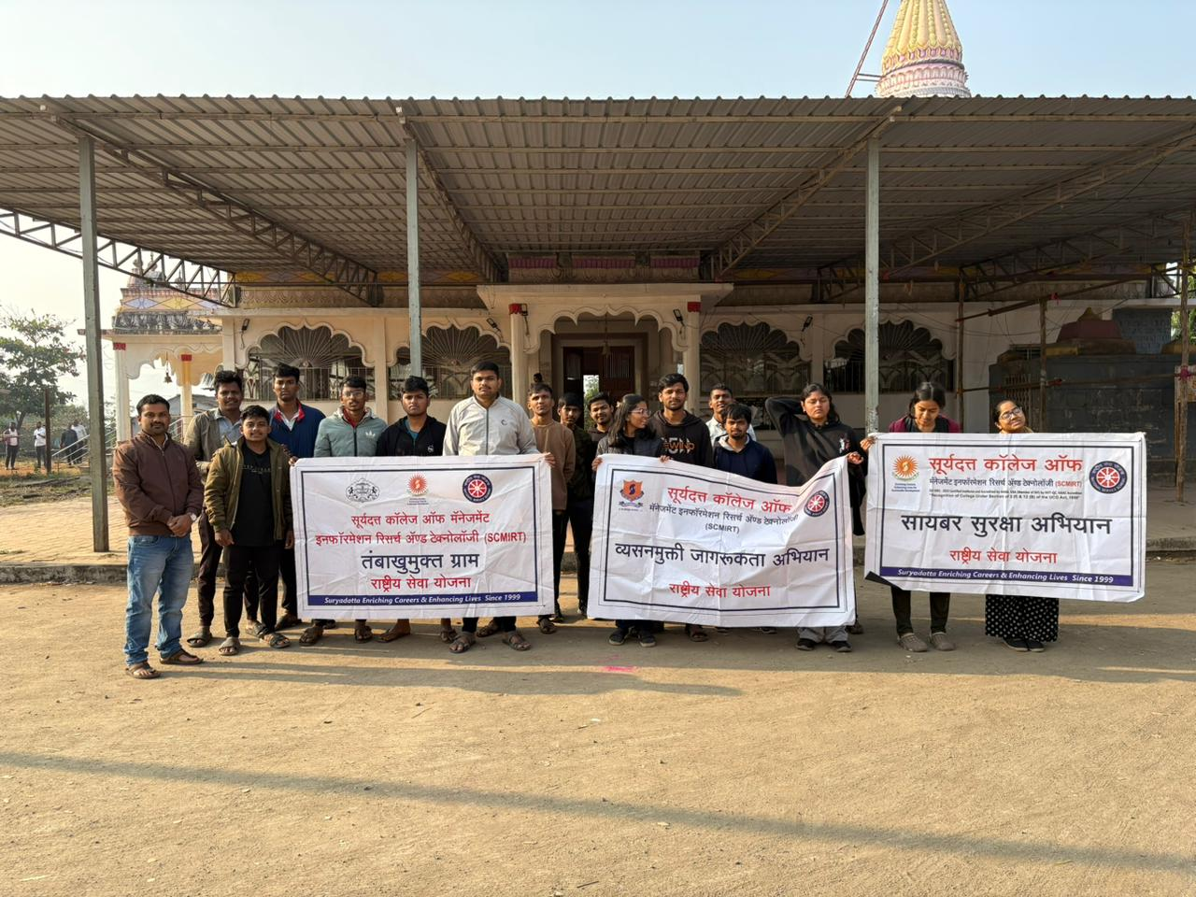
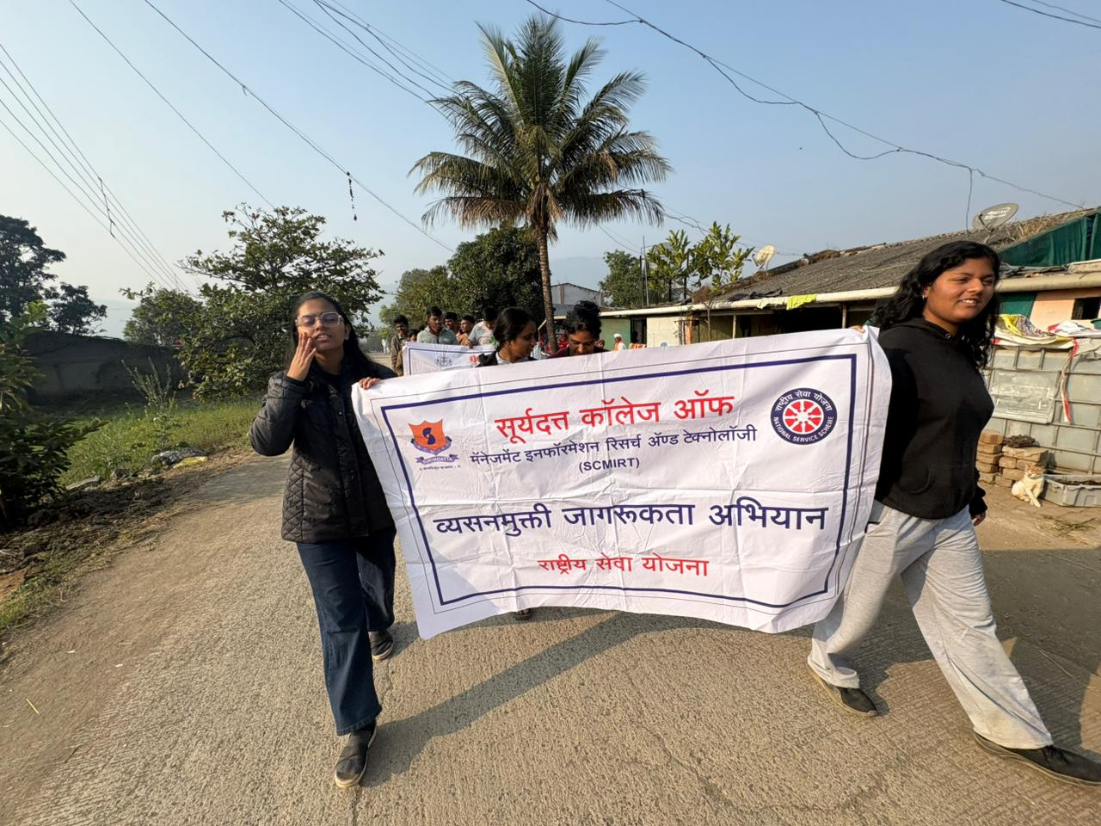

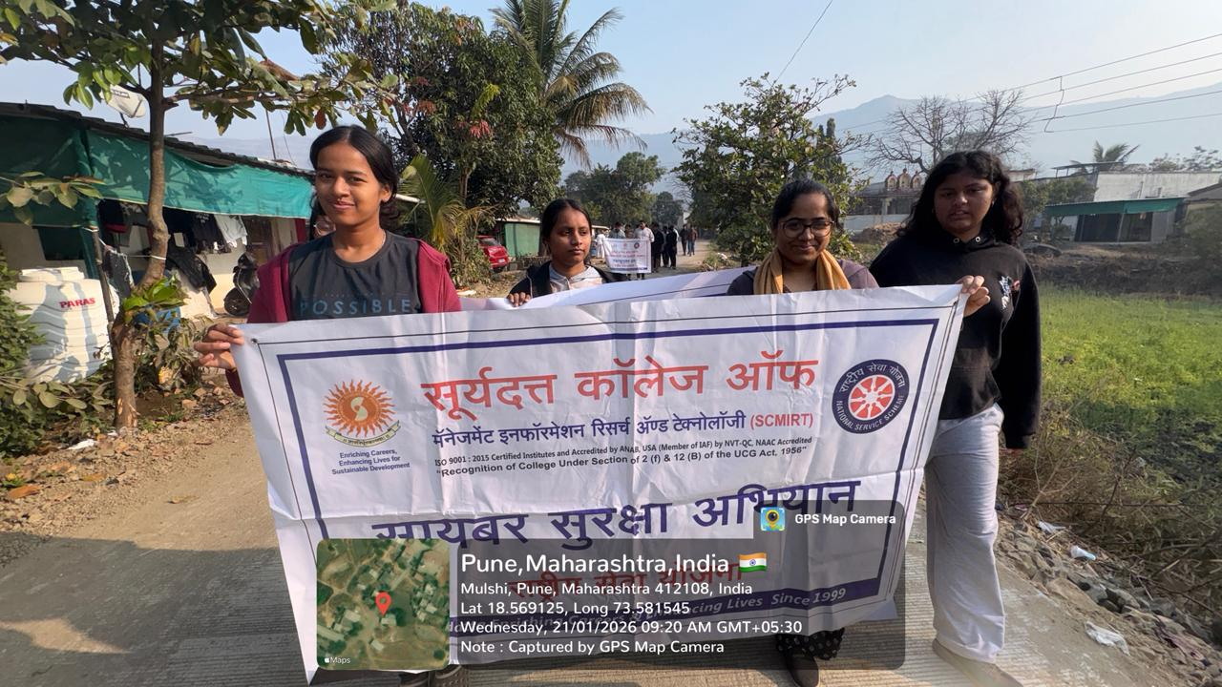
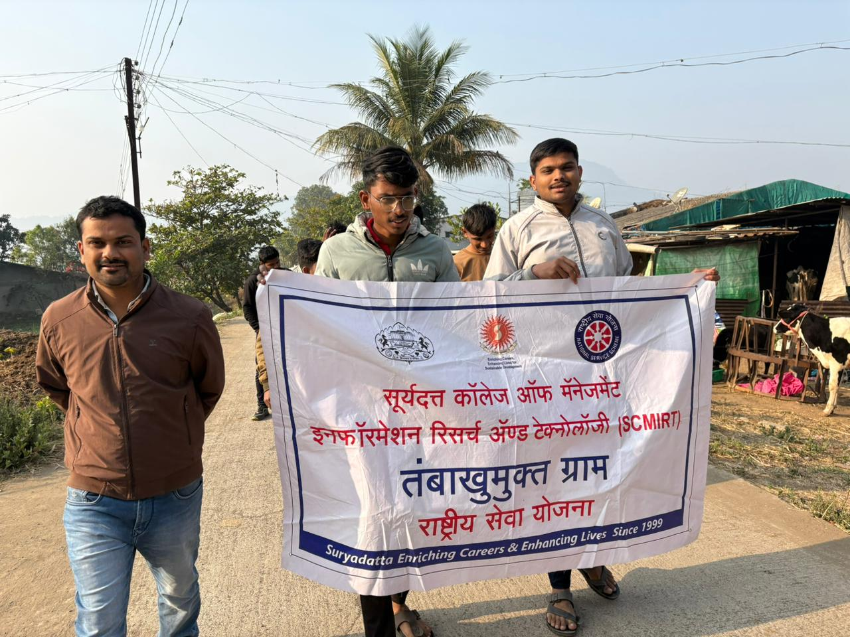
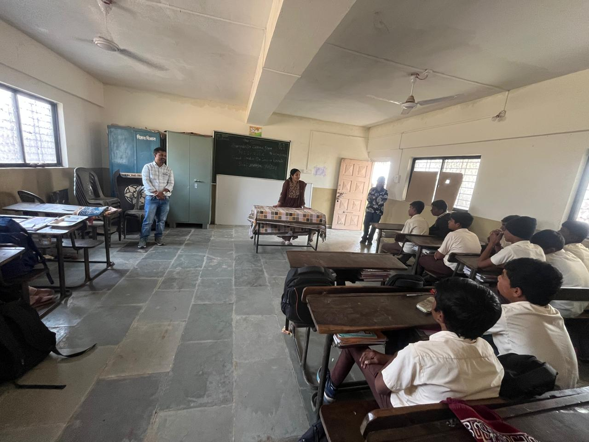
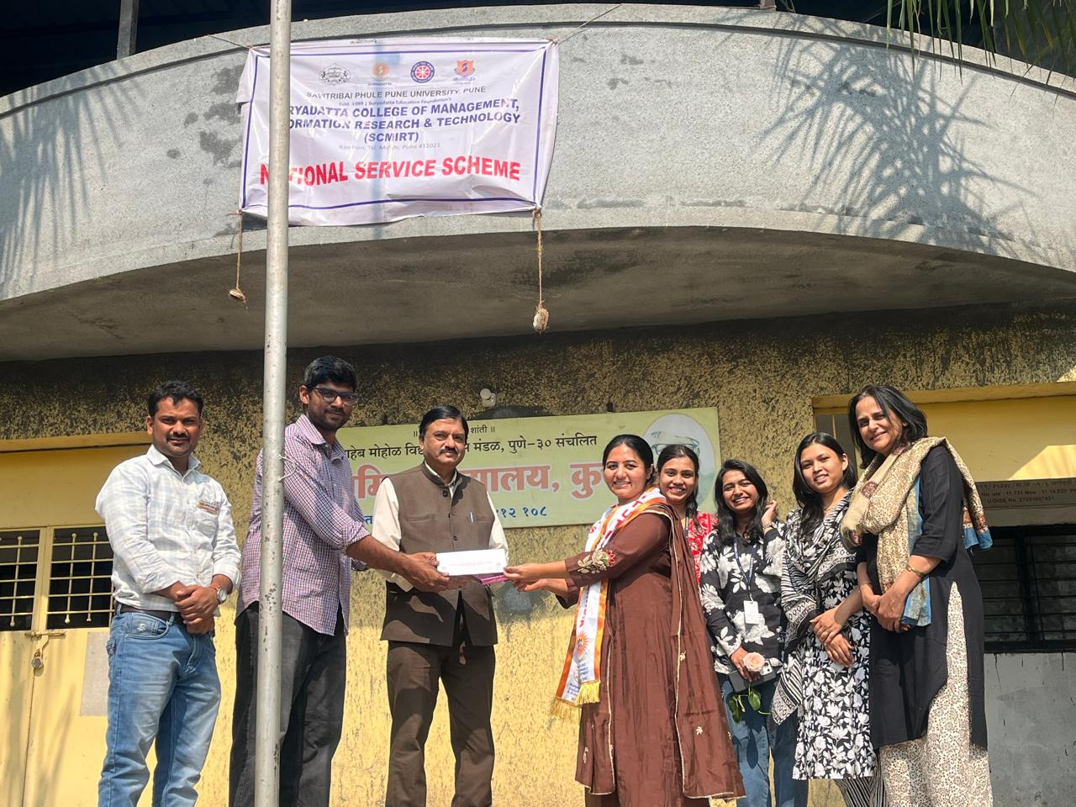

Day 6 (21/01/2026): Cultural Activities and Community Interaction
NSS Volunteers started their day with their regular activities. Warm up, exercise, Cleaning, water storage, etc activities took place. After that, School teaching activity and various fun Games were conducted by volunteers for ZP school students. It took place from 11:00 am to 2:00 pm. Lunch winded up at 4:00 pm. Volunteers helped in washing vessels as well. Volunteers interacted with the students and tried to understand their dreams and taught them subjects like art and craft, Maths, English, Dance and music etc. Almost 85 students were participated and enjoyed the various activities of the camp. It was a very beneficiary camp. Cultural programmes such as group songs, street plays, and interaction sessions were organized to strengthen community bonding. These activities effectively conveyed social messages and promoted unity, cooperation, and social harmony. A felicitation of newly elected Sarpanch Mrs. Deepali Sathe was done.
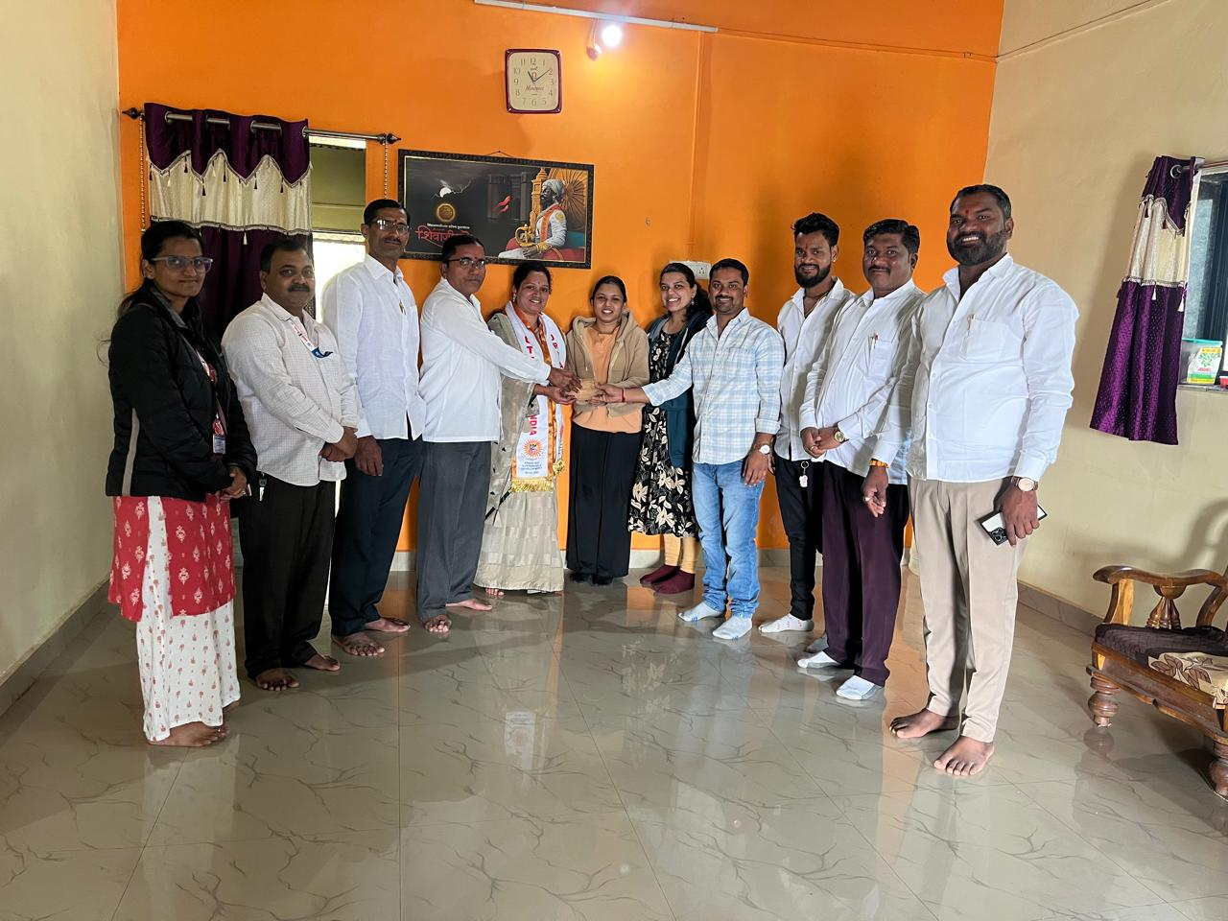
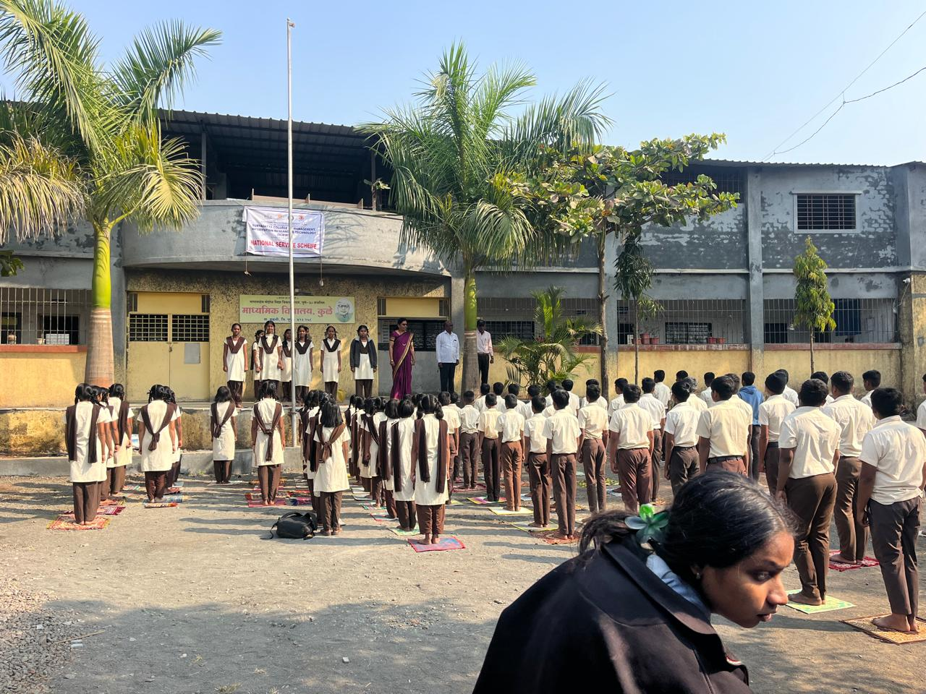
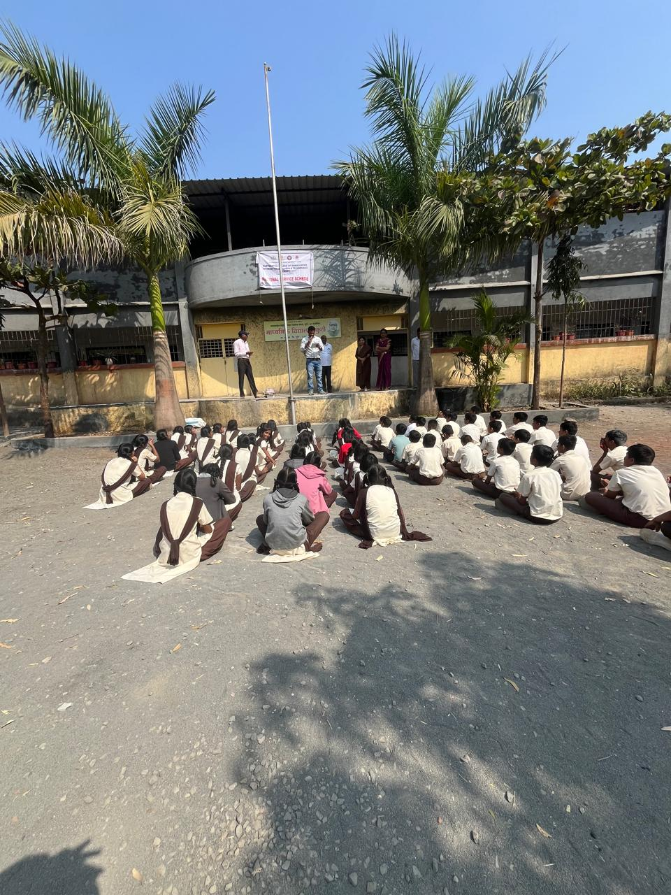

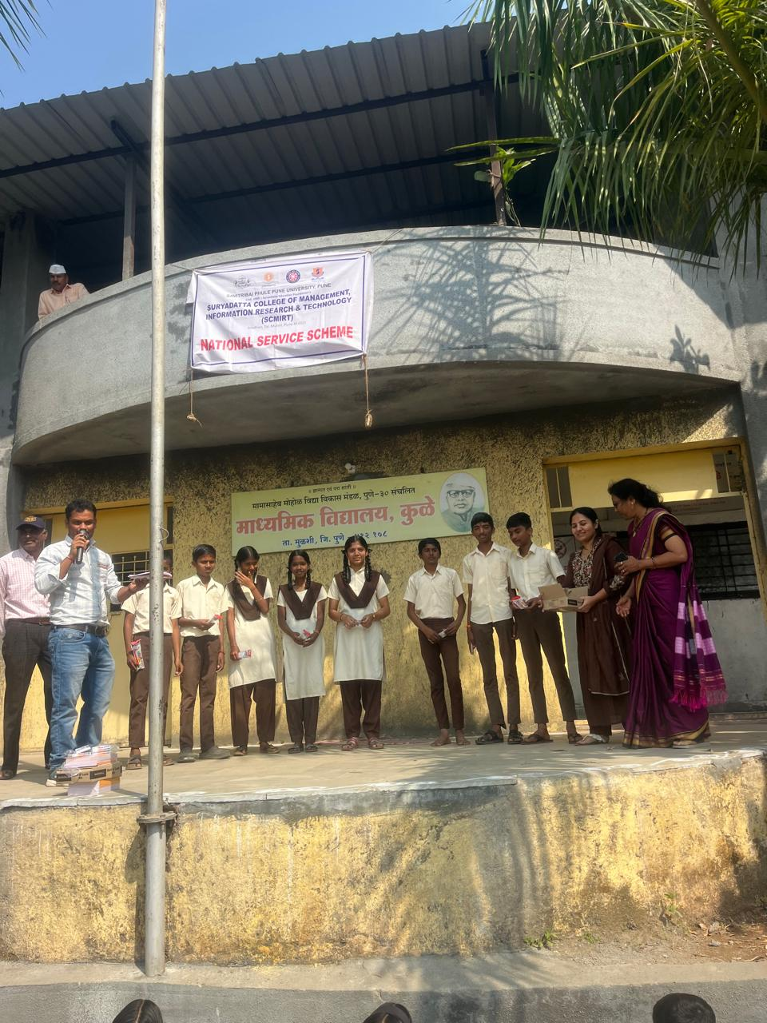
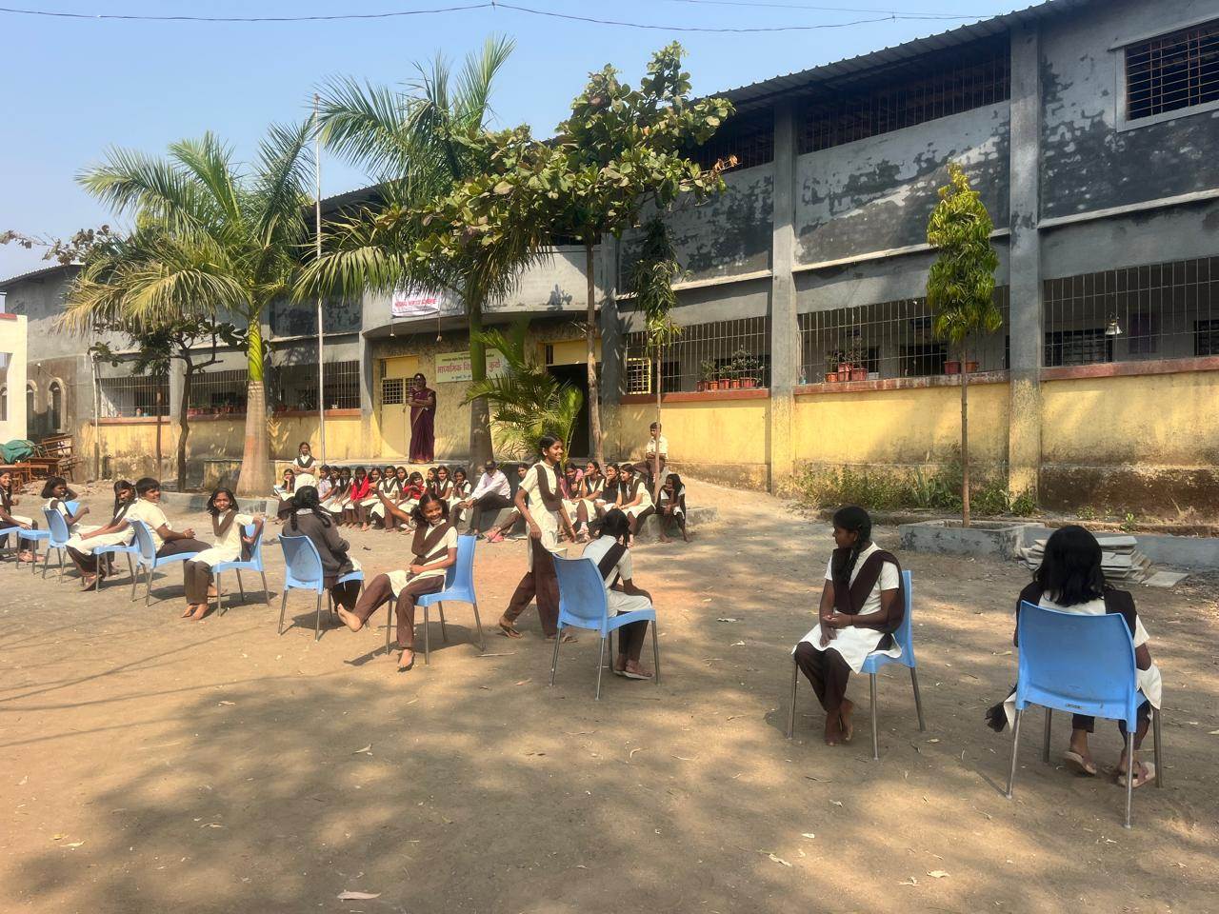

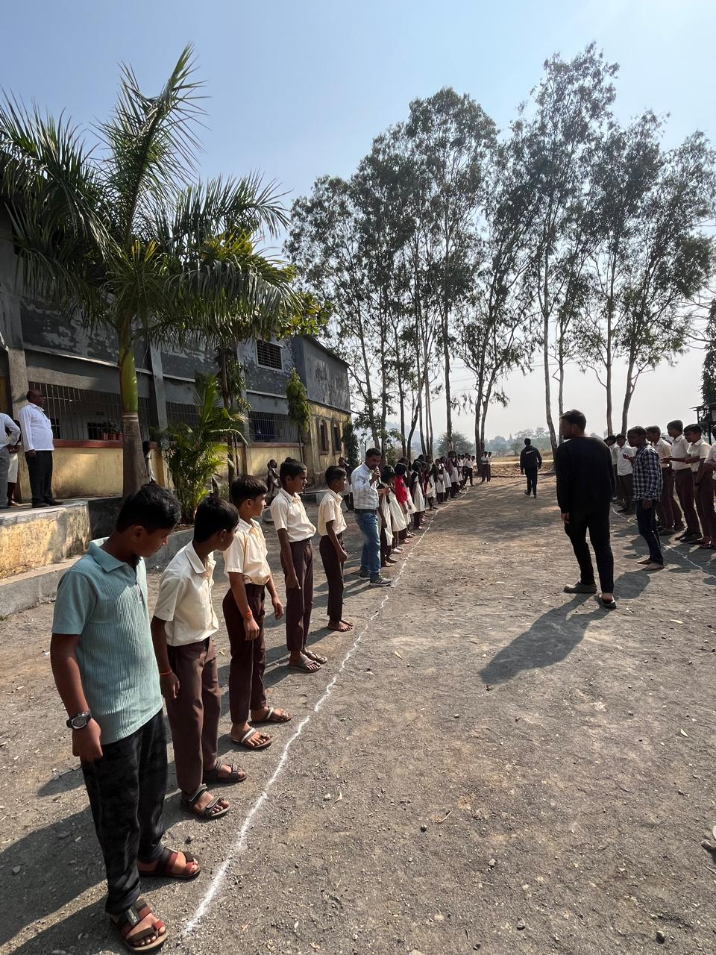
Day 7 (22/01/2026): Valedictory Function and Feedback
The camp concluded with a formal valedictory function attended by village representatives and college authorities. Volunteers shared their experiences and learning outcomes. Feedback from villagers reflected the positive impact of the camp on the community and appreciated the efforts of the NSS unit. The felicitation of Prin.Dr. Shriaknt Jagtap and Prin. Dr. Rasika Gumaste were done by NSS officials.
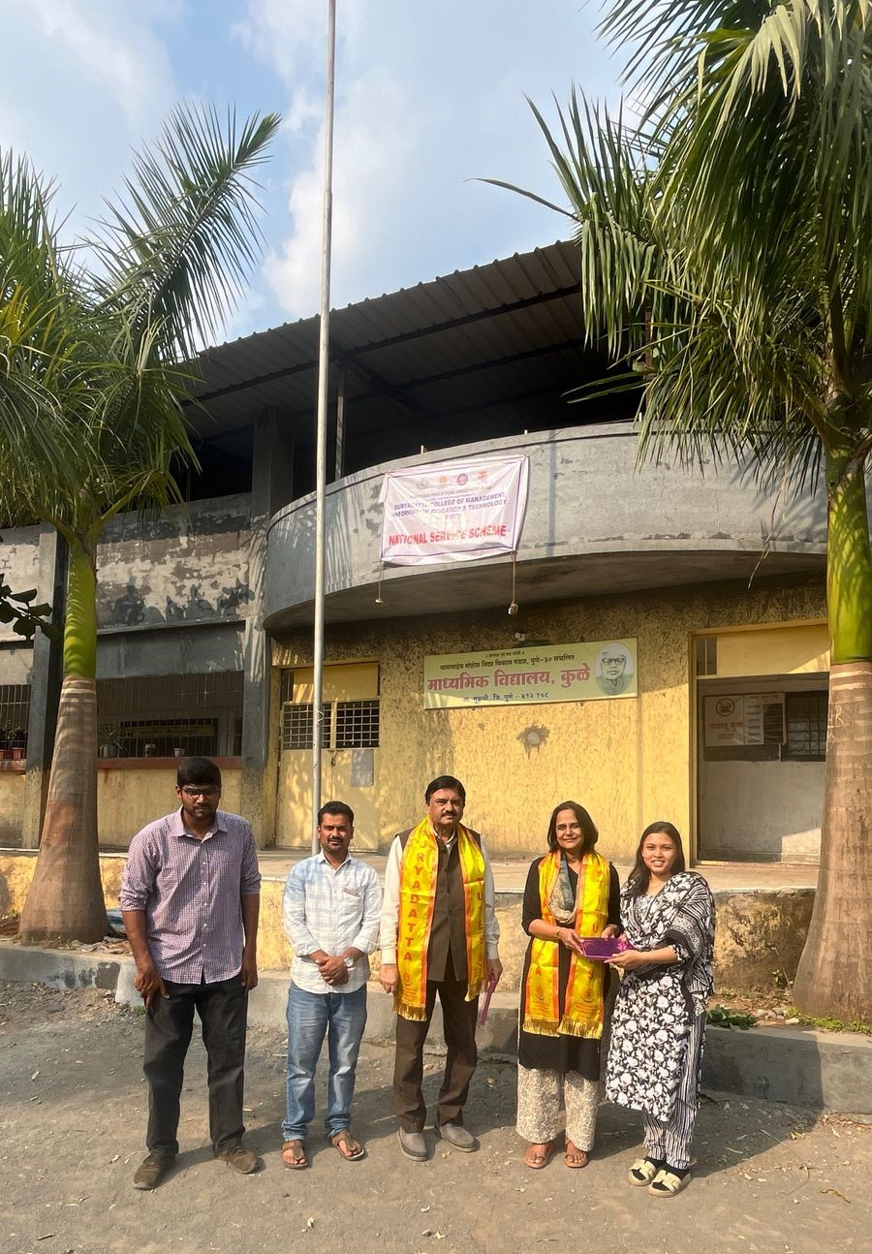
5. Outcomes of the Camp
- Increased awareness among villagers regarding cleanliness, health, and environmental conservation
- Active participation of the village community in developmental activities
- Development of leadership, teamwork, discipline, and communication skills among volunteers
- Strengthened rapport between SCMIRT, Pune and the local community
6. Conclusion
The Seven-Day NSS Special Camp at Kule village organized by the NSS Unit of SCMIRT, Pune from 16/01/2026 to 22/01/2026 was highly successful and purposeful. The camp provided NSS volunteers with practical exposure to rural life and social issues while reinforcing the core values of the National Service Scheme—Not Me, But You. Such initiatives contribute significantly towards community development and nation-building.

Submitted by:
Dr. Sandeep Dhore
Programme Officer, NSS
SCMIRT, Pune
Date: 24/01/2026

